Leadership and successful project delivery
There’s a trend developing amongst the bit of the NHS I get to see. They like to see a party-piece at the start of every job interview. Having had to do ten minutes on “The Leadership Qualities Required for Successful Project Management”, it seemed a shame to let it go to waste. So I give you:

Leadership and successful project delivery – Integrity, Competence and a whole bunch of other stuff as well

Integrity
Integrity and shame are the premier methods of anchoring the self,
Without integrity everything is acceptable,
Without shame anything is done.
Ouyang Xiu (1007 – 1072)
Integrity is doing the right thing, the honourable thing. It’s hard to define, even harder to fake. People recognise it when they see it. It differentiates leadership from management.
(Ouyang Xiu is considered to be a prime example of the Chinese ideal of the multifaceted scholar official, equivalent to the Western ideal of the Renaissance man.)

NHS Leadership
Leadership is at all levels
Care for staff, they will care for patients
Staff who feel supported & valued are engaged
Create an environment of care – driven by our shared purpose, which underpins our sense of leadership & how it relates to change
NHS Leadership Academy
So…. What kind of leadership do we want in the NHS?
Recognise that it’s leadership at all levels of an organisation or service, not just from the top down.
Leaders who care for their staff and have staff who feel supported and valued are engaged – this enables leaders to create an environment of care – which is driven by OUR SHARED PURPOSE.. This is the underpinning sense of leadership and how it relates to change.

The NHS Leadership Framework
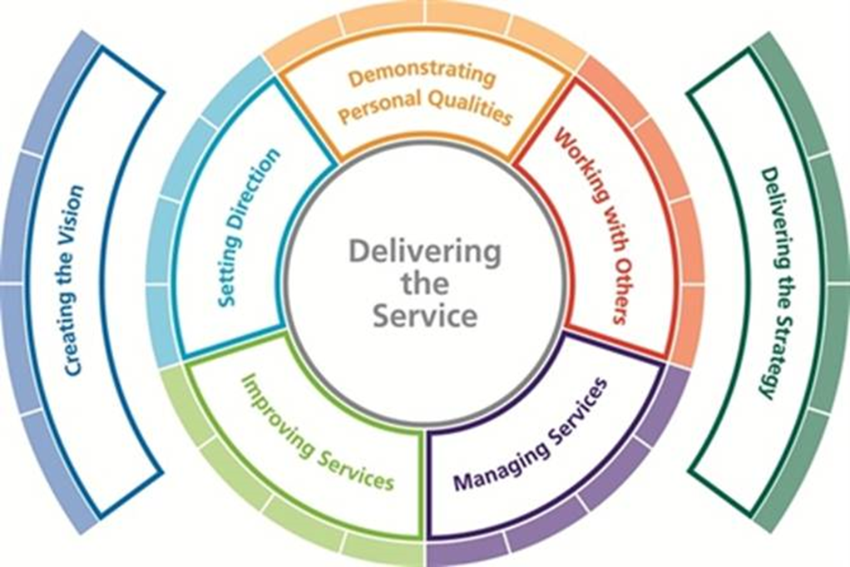
This is a model I recognise and use, hence the ‘bunch of other stuff’.
The Leadership Framework provides a consistent approach to leadership development for all staff in health and care irrespective of discipline, role, function or seniority and represents the standard for leadership behaviours to which all staff should aspire.
Like the change model, the Leadership Framework relies on the alchemy of these elements coming together.
Key - leadership is not restricted to people who hold designated management and traditional leader roles.
Leadership is most successful wherever there is a shared responsibility for the success of the organisation, services or care being delivered.

Six Leadership Styles
Directive (Coercive) - Immediate compliance
Visionary - Providing long-term direction and vision for employees
Affiliative - Creating harmony among employees and between the leader and employees
Participative (Democratic) - Building commitment among employees and generating new ideas
Pacesetting - Accomplishing tasks to high standards of excellence
Coaching - Long-term professional development of employees
One size doesn’t fit all. Context matters (but integrity matters more, don’t swap personalities too blatantly).
The Academy has done some work to look at our existing leadership capacity and capability, firstly through the NHS Top Leaders programme to ask the question, ‘What do we already know about our leadership makeup’?
They worked with Hay Group who developed diagnostics and identified 6 styles of leadership behaviours which can be drawn on at different times, with different people and in different situations. A successful leader would have at least four of these styles that they can draw on.
Of over 2,000 leaders – only 23% of them had an extensive breadth of repertoires with a tendency for ‘pacesetting’.
Pacesetting can be incredibly effective for a period of time, but may not be the key skill needed for change. The downside of the pace-setting style was that it could leave staff “disempowered” and “left behind”, and recommended they broaden their range of management techniques.

Same Change, Different Intentions
The different styles bring us to WIFM, What’s In It For Me? In any big portfolio there will be lots of agencies involved, all with their own desired ends, all able to influence the results. And the impact cascades down through programmes to the projects.
We need to build a social contract between them that balances rights and duties into a negotiated common purpose and a common good.
This is why we need different styles.

“Events, Dear Boy, Events”
Timing is everything. A sense of urgency is essential. Even when everyone is working well together there’s no guarantee of success. Projects are not just a matter of emotional intelligence and playing nicely together. The world moves on.
Priorities change – the NHS gets reorganised, national and local objectives change and budgets are adjusted.
Then there are the nasty surprises, your small surplus turns overnight into a multi-million deficit. Been there, seen that, not pretty.
What this means in practice is that Execs switch focus to the next big thing, the project gets de-scoped and people and resources are taken away, fear of spending overcomes enthusiasm to invest, implementation becomes JFDI.
This means bundling your results into packages that can be delivered to a schedule. Don’t put everything to the end of the project. This is Agile for Business Change.

Set Sensible Limits
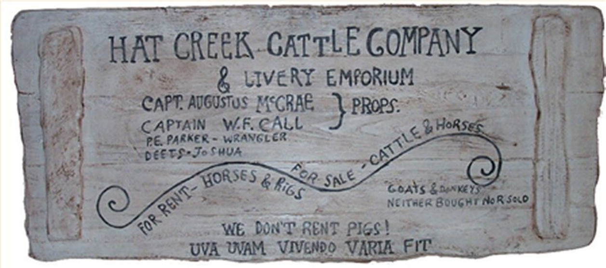
“WE DON’T RENT PIGS!”
Lonesome Dove, Larry McMurtry
A sense of proportion, stretching targets but keeping it feasible.
Knowing when to say, “No”.
Saying, “No”.
Knowing when to say, “Yes, and there’s more”.

Reputation
People will follow charisma. Charisma is hidden in the Leadership Framework as ‘Displaying personal qualities’.
For those of us who lack the physical presence the alternative is Reputation. In these days of celebrity it’s not made much of, but good leaders have a reputation for being good at something. It may be work related but it doesn’t have to be. It’s the being good that matters.
That’s not to say that you don’t have to be good at your profession.

Competence
‘Good-morning; good-morning!’ the General said
When we met him last week on our way to the line.
Now the soldiers he smiled at are most of ’em dead,
And we’re cursing his staff for incompetent swine.
‘He’s a cheery old card,’ grunted Harry to Jack
As they slogged up to Arras with rifle and pack.
But he did for them both by his plan of attack.
“The General”
Siegfried Sassoon
My final choice is competence. All the people skills in the world won’t help if you’re doing the wrong thing in the first place.

