Benefits Mapping – a Force Multiplier
‘Force multiplier’ is a term you occasionally see in defence articles. It sounds impressive and is usually used to describe a good thing. So, what’s a force multiplier in business terms, and where can you get one?
First, a bit of explanation. One official definition of force multiplier is:
“A capability that, when added to and employed by a combat force, significantly increases the combat potential of that force and thus enhances the probability of successful mission accomplishment.” (JP 3-05.1) (US DoD)

In effect, it means doing more with what you have, or doing the same with less. Let’s use an example. You run a minor Eastern-European power in the 1800s. You know that Napoleon’s army is coming for you, but you don’t know where or when, so you don’t know where to put your troops. You can either spread them along the border where maybe one of them will get to watch the French march past. Or you can concentrate them in a few places and hope that the French blunder into them through sheer luck. Lots of troops, not much useful force, very little chance of success.
However, if you have cavalry things look much more promising. A screen of men on horses patrolling along the border will spot Napoleon and give you enough warning to move your army to meet him. Same number of troops, much more force, a fair chance of success (no guarantee of course, we’re talking about Napoleon on the way to Moscow here). Cavalry reconnaissance is an excellent example of a force multiplier.
OK, so how does this fit into your situation? As a boutique IT developer or the Education Dept of a modest borough, you’ve little use for cavalry (though it does raise the tone, and sabres and large horses may have possibilities in secondary school discipline…). What you need is something that improves your strategic choices, that puts your scarce resources in the right places, so you increase their potential and enhance your probability of success.
And so, I come to benefits mapping. The Benefits Map or Benefits Dependency Network is one of the key tools in Benefits Management, but it isn’t used as often or as well as it should be. It’s easy to draw one up as a picture of your project team’s discussions. However, its value lies in using it evaluate these discussions. Take it apart. How rational are the connections, how sound are the choices? What you learn from deconstructing an old map will help you use a new one to make better decisions.
Mapping your decisions
Putting all the relevant stuff into one picture is, by its very nature, holistic. You see how it all fits together. You can see which problem you’re trying to solve and how well your chosen objectives will solve it. You can see from this sort of picture that the old and sadly familiar objectives, “Install kit to time and cost” or “Transform digitally” aren’t quite as strategic, or rational, as many people believe.
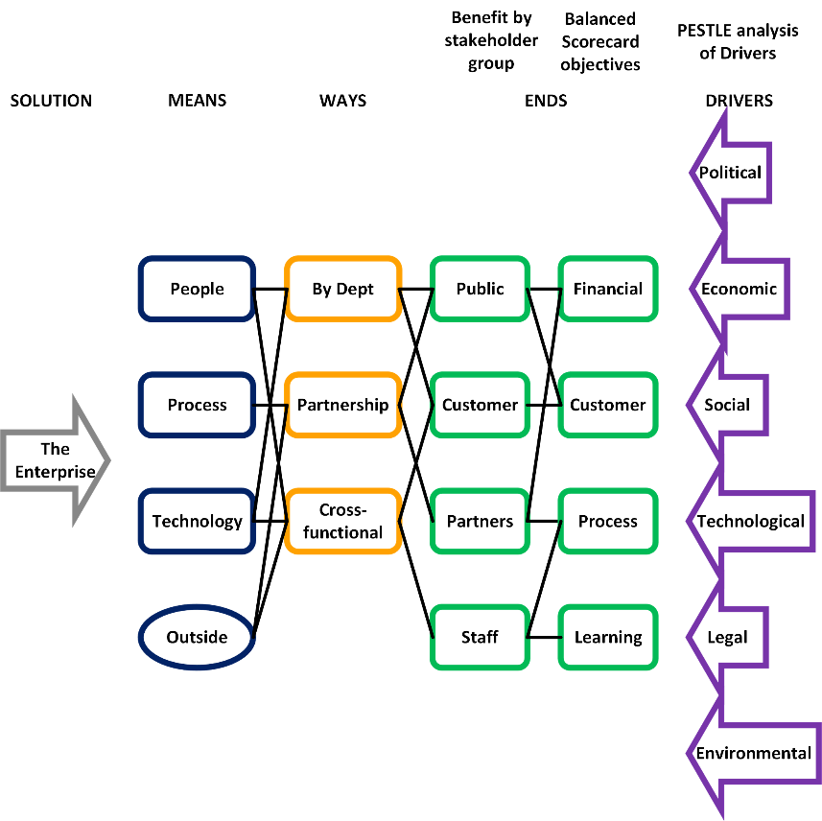
The Benefits-led Enterprise
Here’s the basic model; a PESTLE analysis of what drives your need to act, Balanced Scorecard breakdown of appropriate objectives, one stakeholder group per benefit to separate genuine benefits from the ways and means that create them, the nets of rational cause-effect links between them.
So, how is this a force multiplier? Think of it as more of a campaign map than a benefits map. Taking our Napoleonic analogy, the Drivers are what your cavalry tells you about Napoleon, where he’s going, what he’s likely to do to you. The Objectives are your rational response to the Drivers, the purpose behind the battles you’ll fight, based on the Means (how big your army is) and Ways (where you put it, how it fights). The Benefits prove the value of your Objectives (you won’t win, but you might get the best possible peace treaty).
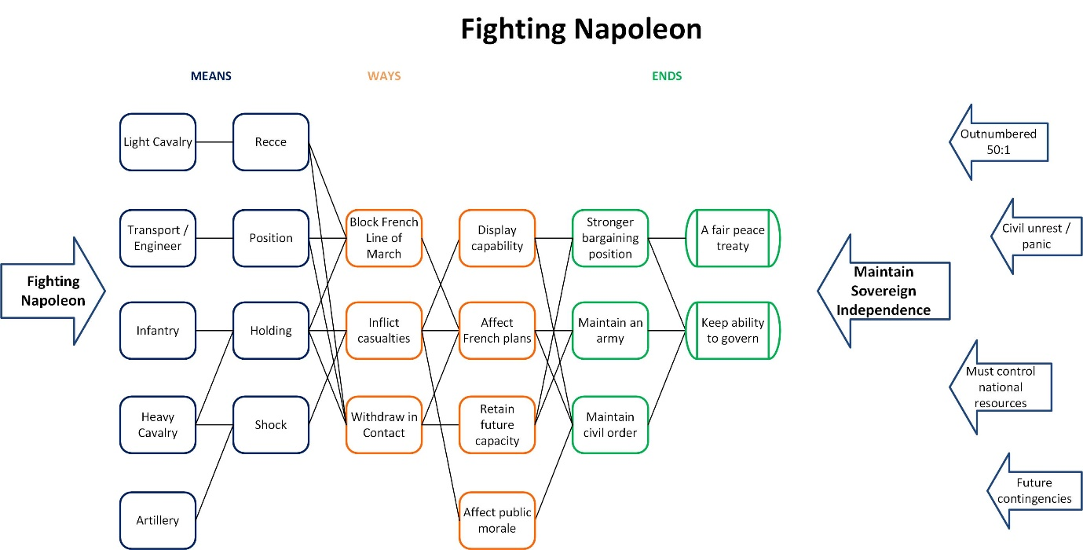
The Benefits-led Principality at War
This is the project to fight Napoleon mapped out: a sensible best-case mission to maintain your independence, two feasible objectives to accomplish the mission and a rational battle to achieve your objectives.
Back at our boutique IT shop and local government department; the Drivers come out of the business environment in which you operate, your Objectives are how you thrive or survive in that environment, Means and ways are your resources and how you use them, Benefits again prove the value of your Objectives. What you do is worthwhile to the right people.
I said that mapping isn’t done as well as it could be. That’s because it’s often done by people who haven’t had enough practice.
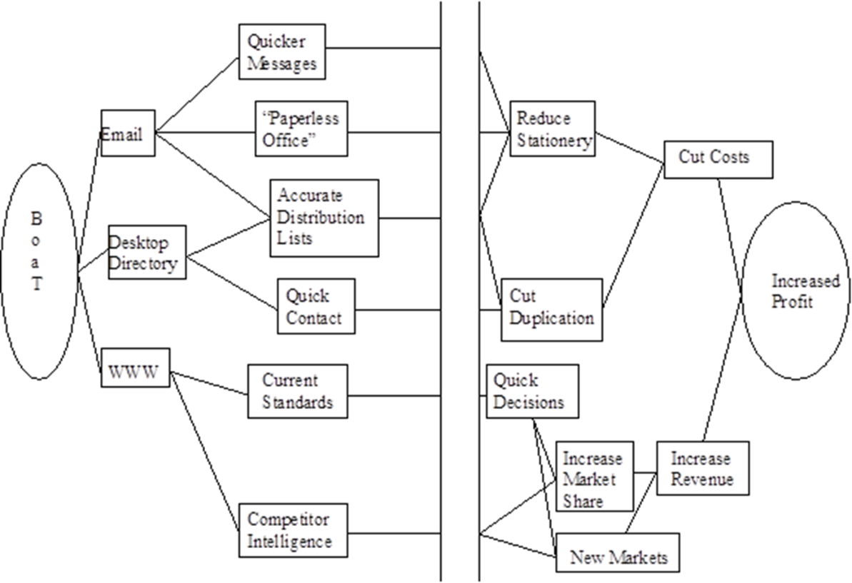
My first Benefits Map
And here’s an example, my first map, drawn in 1996. BoaT (an inspired acronym), Office Automation in BT was BT’s intranet programme. On the left are the things I thought it would do, and on the right, the reasons why I thought it would be wanted. The big gap in the middle was for my various users to show how they were going to use it in practice.
Let’s say that it ‘lacks elegance’ and I do a better job these days. I only leave a gap now if I’m making a point about the things we don’t know, but should. Also, I don’t make up so much on my own. I encourage a lot more stakeholder participation. After all, the map describes their lives, not mine.

Six Dumb Questions again
I wrote elsewhere about the Six Dumb Questions that can be asked of any change initiative. The questions may sound dumb, but the answers need to be clever. They are a great way to test your results:
- What does ‘good’ look like around here? The business context in which you operate
- What’s the point of this change? The stuff you are going to create
- Who is it really for? A thorough understanding of the stakeholders
- What do they actually want? A thorough understanding of perceived needs / wants
- How do we get this done? Governance, resources, know the solution is feasible
- What makes this option better than Plan B? Best use of scarce resources

See how the questions overlay the map:
- What does ‘good’ look like round here? - Drivers
- What’s the point of this change? – Enabler, Features
- Who is it really for? What do they actually want? – Objectives and Benefits
- How do we get this done? – Means and Ways
- What makes this option better than Plan B? – The whole map

Here’s an old example about using IT to improve ambulance services.
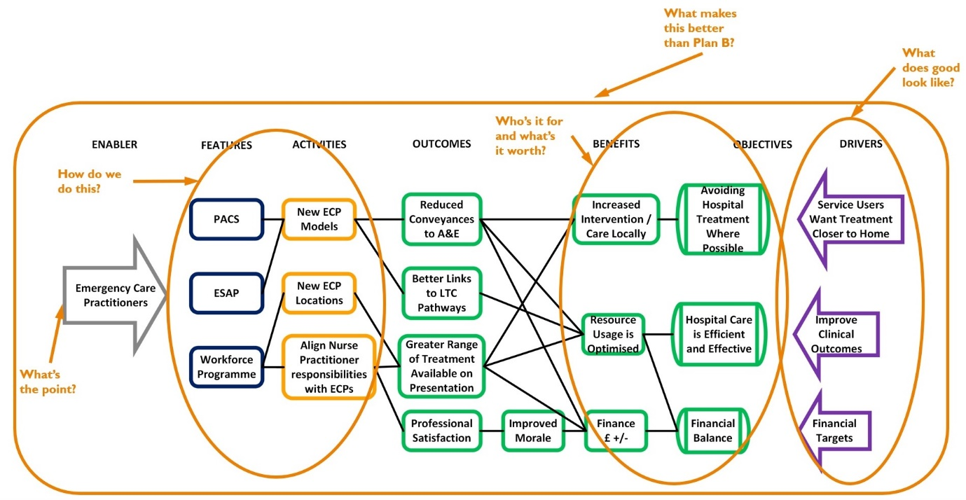
Six Dumb Questions on a Benefits Map

See how the programme stacks up:
- What does ‘good’ look like round here? – People generally don’t want to go to hospital. If they do go, then they should get good treatment. This is the NHS, so money will always be tight
- What’s the point of this change? – A named programme that implies the boundaries. We’re not doing anything outside Emergency Care Practitioners
- Who is it really for? What do they actually want? – This is for the leaders who commission and provide ambulance services who want improved effectiveness and efficiency
- How do we get this done? – A mixture of people (Workforce), process (ESAP patient assessment) and technology (PACS digital imaging) means, that support new business process ways
- What makes this option better than Plan B? – The whole map works. Sensible and economical means and ways produce valuable ends. It looks like a rational story and a good investment

The map, done well with sufficient thought and practice, is an excellent tool for multiplying the effect of your business decisions. Try it out, share your maps with colleagues, borrow from others, learn and improve. It’s definitely worth the effort.

