The Decision Project
Strategic decision making is a cerebral activity. It uses brains as its prime resource. We may apply time, money, people and machines to help us form our decisions but all the hardware and software in the world will count for nothing if the 'wetware' gets the initial connection wrong.
Once a decision is taken, we have many tools and methods to see it is made concrete. These tools are often seen as prescriptive and controlling. We set tasks, milestones and deadlines to ensure the right activities are done at the right time. But what tools and methods do we use to create the decision in the first place? Western leadership style expects these decisions to come from flair, imagination and creativity and we are reluctant to tie them down with process.
You would expect the Military to do things 'by the book' so what does 'the book' say? Here's a quote from the US Army:
“Decision making is knowing if to decide, then when and what to decide. It includes understanding the consequence of decisions. Decisions are the means by which the commander translates his vision of the end state into action.
Decision making is both science and art. Many aspects of military operations - movement rates, fuel consumption, weapons effects - are quantifiable and, therefore, part of the science of war. Other aspects - the impact of leadership, complexity of operations, and uncertainty regarding enemy intentions - belong to the art of war.”
So one could say that the predictable repetitive stuff belongs to science and the creativity belongs to art.
But we can't rely on artistic genius to see us through. Assuming we could ever define and measure decision making skill it would still be a depressing fact that half of us would be below the median. We need some structure to help us choose the right things to do. I want here to consider decision making as a project in itself so let's start with a description to set the scene.

Characteristics of projects
Projects have a defined start and finish. When the project is complete, the project manager hands over to the client who is then responsible for achieving the benefits. Projects are unique and tend to have significant novel features, are risky and have an in-built uncertainty and can change as the work progresses.

Managing Subjectivity
So, is decision making a project? It has defined resources, a start date (possibly hard to identify afterwards) where the idea begins to form, "I think we should do something" and an end date, the point when the decision is taken, "This is what we'll do".
The role of Project Manager is taken by the decision maker, i.e. the Senior Executive, Board or Steering Committee who decides what business change will be implemented. The Client is the process owner, the management team who make the business change happen in practice. Once the decision is made the project is complete, the Decision Maker / Project Manager moves on to the next one and the delivery of benefits from the change is left in the hands of the Process Owner / Client.
We are continually making decisions and so it might seem that it ought to be a process but the variety of type, timing and participants implies that it is a rolling programme of activities, with each decision a project in its own right.
If we treat each decision as a project then we should look to a rational method for its successful delivery. Given that strategic decision making is a human activity, we can never entirely eliminate human weaknesses and strengths. There is no workable production line that churns out good decisions. We are faced with human subjectivity throughout the decision project lifecycle. Here we concentrate on the two key points, knowing where to start and knowing when to stop.
The Subjective Start - choosing the right problem
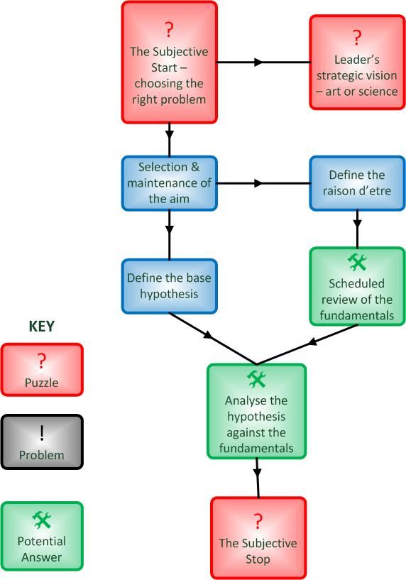
Inception & feasibility
The trigger that starts the research and planning processes may itself be subjective. This is where the 'in-flight magazine' school of portfolio selection often appears. The CEO reads something that strikes a chord; 'Everyone who's anyone has an intranet', 'The pink pound is an untapped market', '6 sigma is the new TQM'. Everyone then jumps to deliver this vision without analysing how valid it was in the first place.

Leader's strategic vision - an art or science?
Visionary leadership smacks of the cult of the personality. We reward individuals, be it with knighthoods or Oscars. For all the rhetoric of, "I accept this on behalf of…", there's still only one trophy and one mantelpiece on which to put it.
Leaders have vision, they see where the organisation must go and what it will be. Then the managers act to deliver the vision. Many popular descriptions of leadership boil it down to having that flash of inspiration and sweeping everyone along with it, "I saw the gap in the market and went for it!" The business press, like other media, looks for a good story and good stories need heroes. Very few published interviews with CEOs say that their vision is based on rigorous, unemotional analysis by a team of equals.

Selection & maintenance of the aim
So, what happens if your ego isn't big enough to storm ahead regardless and you want the comfort of rationality? Let's assume your aim is to do the right things for the right reasons. The first thing to do is to establish the context in which you will make your decisions, i.e. establish what the right reasons are.

Define the raison d'être
Get the fundamentals established and recorded. Have your organisation's business drivers clearly defined in a way that everyone understands and can apply to their work. Decide what you are there for so you can stop the recurrent navel-gazing. It's probably best if this is a bit more detailed than the average mission statement. If you know why you should be doing something, it's that much easier to decide what it is that you should be doing.

Scheduled review of the fundamentals
You have to be flexible and respond to changes in the organisation's environment. The world moves on and you don't want to be left behind. Go back and review the raison d'être of your organisation now and again. Do it in a logical manner on a scheduled basis and in response to specific relevant triggers. Do it when the law changes, when the technology changes, when a real gem pops out of the staff suggestion scheme.
Actually refer to the Lessons Learned reports and logs from previous programme and project reviews and apply their findings.

Define the basic hypothesis
This is the point where the light bulb comes on in someone's head. The initial idea forms, either as a piece of individual creativity or a simple desire to follow the competition. It may be influenced by all the context setting work you've done beforehand. It may be pure speculation. Its creator must then articulate the idea for the decision makers to understand, usually starting with a statement of "Why don't we...?"

Analyse the hypothesis against the fundamentals
Does the new idea fit with the raison d'être and present activities of the organisation? If not, does it still have merit? Tesco now sells financial services very successfully, quite a radical step for a grocer. Does it add value? Some formal processes for Value Based Management suffer in that they rapidly descend into accounting ratios without first helping people to identify which activities are actually valuable. However, it's a start in getting you thinking what activities are worthwhile.
If your basic hypothesis stands up, it goes into the latter stages of the decision making project. We move beyond the inception and feasibility phases and into planning of the final decision.

The Subjective Stop - choosing the final answer
There will come a point when the analysis has to end and the decision made, the “Enough!” point where you stop asking, "Why" and start acting. The trick is in knowing that you've reached the right point at which to stop. Our decisions satisfy and suffice. "It will do", wins over "It's the best", simply because we haven't the time, resources or knowledge to make perfect decisions.
Occasionally, the best is enemy to the good and satisficing courses are not taken. Ethics, precedent setting, even simple cussedness may block a pragmatic decision in an attempt to get all or nothing.
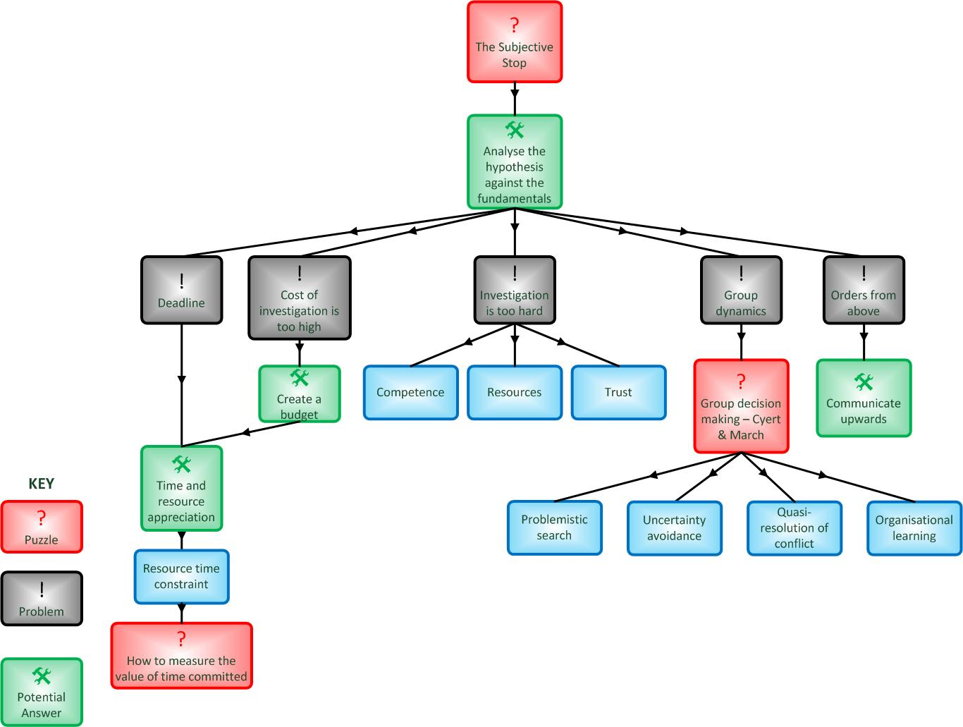
Definition to Rollout
Taking the decision project from the part where we were analysing the basic hypothesis, what factors bring us to a subjective stop and what can we do about them?

Deadline
Do you have a deadline to meet? This may be a specific date or a window of strategic opportunity, e.g. to act before the competition moves. It may be that the deadline is so crucial that it determines the original decision. Obviously, you are not going to be doing this in a time of crisis or emergency, like jumping out of the path of a bus. You should have at least a few minutes in which to decide. If someone is pressing you for an instant answer, then they probably know the answer they want and it’s unlikely to be a good one for you.

Time & resource appreciation
The first action when given a task should be the time appreciation, "How long have I got?" If you haven't got an imposed deadline then set yourself a reasonable timescale and don't leave things open-ended. At an individual level this may be to make a significant positive impact before your next job appraisal. In political terms it's to achieve something before the next election campaign starts.
The second action is to identify the resources you have, who, what, how much. You can then move on to choosing your resources to make best use of the time allowed.
Most of the resource in decision making is people. They will have other commitments so you have to find out and agree their availability to your decision project. When you take them away from their day jobs you have to consider the opportunity cost of their time. What would they be doing if they weren't in your meeting? Don't forget to include this in your cost of investigation.

Orders from above
Often the limits will be set for you, deadlines will be changed and resources re-allocated. Sometimes, the entire decision will be taken out of your hands. It's important that you communicate upwards on a regular basis so that in the overall programme of decisions yours gets the attention it deserves.

Cost of investigation is too high
There is a danger that you could spend more in analysing the decision than the incremental benefit it will provide. With infinite resources your investigation could go on forever. One way round this is to treat the analysis as a budgeted activity and limit it to an acceptable proportion of the expected benefits. If you think your decision will bring in £10,000 savings then it's worth investing £1000 in getting the decision right.

Investigation is too hard
Sometimes you have to admit defeat and move on. The decision project fails to reach a conclusion and is closed down. This may not be a bad thing. It may batter the ego a little but it's better to stop than throw good money and effort after bad.

Resources
The time and effort of research outweigh the benefit the decision will bring. You can't spare the time or staff to do it. This will be helped by setting a budget for investigation. However, circumstances change and you may lose key staff at a bad time.

Competence
The scope of the decision project falls outside people's skills and experience. It's a simple fact of life that we can't all be good at everything. The person who interviews senior executives and has them pouring out their hearts won't necessarily be any good at scouring academic journals for the latest theories. Look for a breadth of competence as well as quality in your decision making group.

Trust
Do you trust the input data, is it accurate, complete, relevant? Do you trust the analysis processes, are they sound, have they succeeded in the past? Do you trust the analysts, are they competent and objective? Do they have the right motives? And if you don't trust the data, why not? Are your reasons fair, rational and unprejudiced?
When given the choice between a team of experts with years of collective experience or a journalist with a deadline to meet, why do we so regularly pick the journalist's point of view? Often, style wins over substance so we should try to avoid rash judgements based on too little analysis of the data.

Group dynamics
Very few decisions come from one individual mind. Even if you work alone, you will be influenced by those around you. There are many works on group dynamics that you can refer to when watching the team in action. One that is good for decision making teams comes from Cyert & March. They acknowledge that decision making isn't a completely rational process as far as the organisation as a whole is concerned. If we accept that the organisation is a shifting coalition of interests with many individual and group goals then the decision making process will fall into four areas.

Quasi-resolution of conflict
We all have to rub along together, either as individuals or work groups. This means we look to reducing or avoiding conflict with those around us. In a work context this leads to local rationality, workgroups solve their local problems, not the organisation's. Like Simon above, decisions are acceptable, not optimal.
To keep the decision making group together the process is kept simple. There is a sequential attention to goals, to fix one problem at a time, rather than considering a holistic solution.

Uncertainty avoidance
No-one likes uncertainty, especially when it involves risk. Short-term means less risk so groups concentrate on the immediate things they know, not forecasts of what might arise.

Problemistic search
We return here to the subjective start, choosing the right problem in the first place. Cyert & March say that the search is motivated, i.e. a problem is seen and spurs the group to reaction. While waiting for the problem to appear we all carry around our own preferences, prejudices and agendas so pet projects go looking for crises to fit and are brought to the table when we think the time is right.

Organisational learning
The organisation learns from its experience and adapts. This adaptation occurs through individuals. Turkeys don't vote for Christmas, no matter how much pleasure they will bring to the rest of us. People change their behaviour to suit the rewards and/or punishments they have received. The last decision they made may have been altruistic and of great benefit to the organisation as a whole. However if its results were personally negative then they will not be motivated to act in a similar manner next time. The next decision may be much more locally or even personally rational.

Pick the team carefully
For all the rational methods we can use, your decisions are going to depend massively on the team that makes them so you have to devote effort to picking the team. This is itself a decision that could send you right back to square one. Try not to put the cart before the horse by picking a team that will simply give you the decision you want. However, you have to consider their competence, skills and the way they will work together. Do not pick them at random and do not settle for the people who just happen to be available at the time.

Conclusion
We live in an ever more competitive world and as such have to come to terms with winning and losing. We are brought up on stories where heroes are winners but there are too few heroes out there and they're probably too concerned with looking after number one.
Strategic decision making starts and ends with subjective events chosen by people, not procedures. By treating the decision as a project, we have a framework to give us confidence that the final decision was the best we could do. Though subjective, it contains a bit more logic than simply tossing a coin.
We have to make do with what we've been given. However, with a bit of thought and preparation though we can more than 'make do'.

US Army Field Manual FM101-5, Staff Organization And Operations, 1997, Chapter 5
Cyert, R.M. & March, J.G., A Behavioral Theory of the Firm, Prentice-Hall, 1963

