Cui bono? Who benefits?

Getting philosophical
The failure of so many projects could be due in part to the fact that we have a poor understanding of what defines success in the first place. We say that Project X failed because it didn’t deliver any benefits. I’m going to take the stance here that all projects do deliver benefits. The problem is that too often they are poor benefits for the wrong people.
A benefit is a result that someone thinks is worthwhile
First, here are a few simple definitions so you can hopefully see what I’m getting at. Stepping away from the definitions of benefit that attribute good benefits to specific programme / project activity, at its most basic level a benefit is a result that someone thinks is worthwhile.
The words goal, objective, aim, all mean similar things and tend to be swapped fairly loosely. Here I use objective to mean a result with a worthwhile purpose. Even if it’s not stated explicitly, there ought to be a ‘because’ statement underpinning every objective. If you say that your objective is to build a bridge then you ought to have good reasons for crossing the river.
Other terms that will crop up later are:
- Enterprise – the collective group that has objectives, as small as a team, as large as a multi-national organisation
- Project – a discrete set of activity to implement a change in circumstances. For simplicity here it covers a project, programme, initiative and change of any scale
- Means – the resources, things, people, and time you have to use, project outputs
- Ways – how you use things, what you have to do
- Ends – the results you want, the outcomes, benefits and goals you want to achieve
- Stakeholders – the individuals and groups who affect and/or are affected by your project. The particular stakeholders here are:
  - Instigator – the entity (person or group) that had the original idea and triggered the project
  - Sponsor – the entity with the power to achieve the ends, to run or cease the project
  - Enablers – the people who support the Sponsor to achieve their ends, either by working directly on the project or providing indirect support by way of resources or encouragement
So why drag you through these dry definitions? Because too often we don’t appreciate the difference between the means and the ends. Take a look at some business cases and chances are you’ll find something like, “Objective: To build the building”, or, “Objective: To install the hardware”. These are the means, they’re not the ends. There’s no purpose to them. And purpose is so very important.

Naïve questions
There are six naïve questions that every project ought to answer to explain itself:
- What does ‘good’ look like round here?
- What’s the point of this change?
- Who is it really for?
- What do they actually want?
- How do we get this done?
- What makes this option better than Plan B?

The first two questions set the scene, the context in which you operate and intent behind the project:
- What does ‘good’ look like round here? Are you working to a Vision and Mission statement? What are the relevant Key Performance Indicators that you want to address?
- What’s the point of this change? Described briefly, in simple language, what will you make?

Let’s start, as all good benefit-led changes ought, with the end in mind. Objectives and benefits, how do they differ? How much should they differ? Which one is the end we should keep most in mind?
Every objective, however perverse, has a purpose that satisfies a stakeholder. There has to be something in it for someone. There are four crude types of objective based on what they intend to deliver.
Objective 1 – Deliver ‘Something’, there are no defined benefits, and the outcomes are indicators of the intangible ‘something’. This could be appropriate when the project is to meet mandatory obligations or obey instructions from above. Or it could just be an example of poor objective setting.
Objective 2 – Deliver ‘Good’, the benefits are evidence or proxies of some intangible ‘good’.
Objective 3 – Deliver the Shopping List, in this case the benefits and objective are the same thing. This doesn’t so much look like the General’s campaign map, more the Quartermasters’ requisitions for kit.
Objective 4 – Deliver Strategic Objectives, something big, important and probably intangible. The Benefits are evidence of action that contributes to the strategy.
By separating out the benefits we affect the approach to objective setting.

- Who’s it really for?
“Who’s it really for?” is the next of the six naïve questions we should ask. We have to keep asking it because the answer is likely to keep on changing, at least in the early stages. If we want to influence things then the follow-up question ought to be, “Who should it really be for?”
Assuming that a benefit is a result that someone thinks is worthwhile leads us to thinking about who that someone is and what they perceive as being valuable.
Nothing is a benefit until someone chooses to make it so

This project will initially have one benefit recipient – whoever starts the project. For the sake of a name let’s call them the instigator. They are also the initial benefit owner. They will be responsible for realising the benefit they want when they conceive the project.
The Inception Benefit
Any change initiative starts with an end in mind. The question is, how good an end is it (for an as yet un-decided definition of ‘good’).

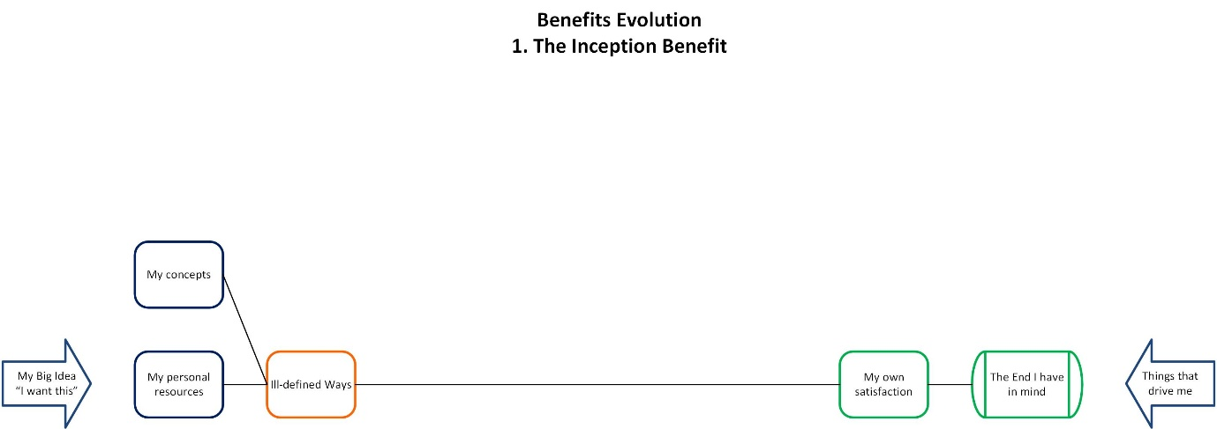

Take our basic definition that a benefit is a result that a stakeholder perceives to be worthwhile. That initial decision to make a change gives us our first benefit. The inception benefit is, “I, the instigator, will achieve my desired ends.” The ‘What’s in it for me?’ is “I get what I want.”
It sounds vague and weak because at the very inception of the change it will be. This is a case of, “I’d like to do…” New ideas rarely come into the world fully-formed.
This is the Big Bang from which our universe of benefits will expand. It’s what it expands into that’s the tricky part.

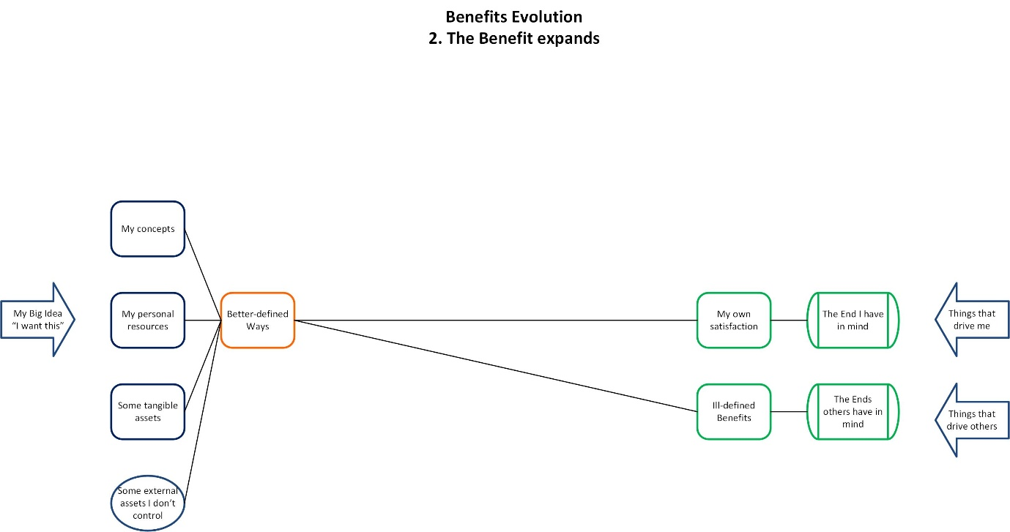

Expansion – Agile iterative benefits
The development of benefits will take place within the development of the project. This is a very fluid environment. People and resources will come and go, the world moves on. Influence works both ways. We don’t have to react to change, we can make change.

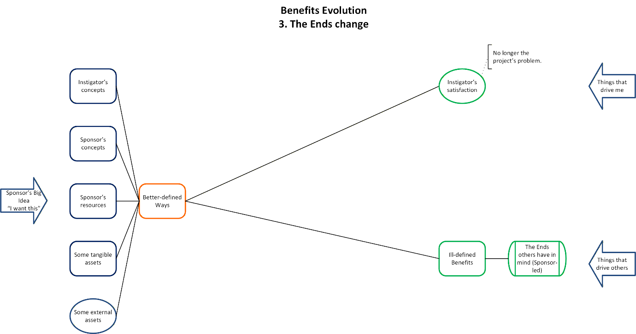

So what’s going to change that we need to worry about?
Control and governance will develop as the project grows. The actual person / group who acts as sponsor may change as the project develops. The instigator may not retain control of the project and become its sponsor. The junior staff member who had the initial creative idea won’t end up leading the corporate transformation programme. There may be a formal handover of control. The project grows so accountability and responsibility move up the corporate hierarchy. More and bigger stakeholders get involved and the balance of power shifts. Accountability means the sponsor acts as a steward on behalf of others. Objectives and benefits become less personal and more corporate, acting for the enterprise.
The sponsor cannot act alone. Enablers join the project to support the sponsor’s behaviour and help the sponsor achieve their ends. The most obvious enablers are the ones directly involved with specific tasks, e.g. the project team who plan and implement the change and the line managers who exploit it in their business. There are other direct enablers above the sponsor who give their approval to proceed and provide the funds. Indirect enablers are the ones who influence the sponsor’s behaviour and decisions. They provide encouragement and motivation, express their preferences for / against the project and its deliverables, change the sponsor’s view of what constitutes success. All these people and groups will, to some extent leave their mark on the end product.
In the end, “Who is it really for?” comes down to this collection of sponsor and enablers. Together, they see that the project exists, direct what it does and can end it if they wish. The value to people outside this group, i.e. customers, the public, only comes about because our enablers permit it. The new widget is not so much what the customers want as what Marketing believes the customers want.

- What do they actually want?
Having accepted who it’s really for, the next question that goes with it is, “What do they actually want?” This is where the definition of ‘good’ plays its part. Do they want the right things, is value being optimised, is it all fair?
Projects rarely recognise exactly who they are for in the way described above so it’s understandable that they don’t know what they want. Going back to question one, the sponsor / enablers may not fully appreciate the context in which they operate. If they don’t know what good looks like, then they won’t act in support of the good. As stewards they ought to do what’s best for their charges, and that means finding out what the best is.
This is where value is lost or even destroyed. The sponsor does not put in the time, effort and skill to select the best objectives and benefits. The enablers do not provide the sponsor with the evidence and guidance they need to make the right selection.

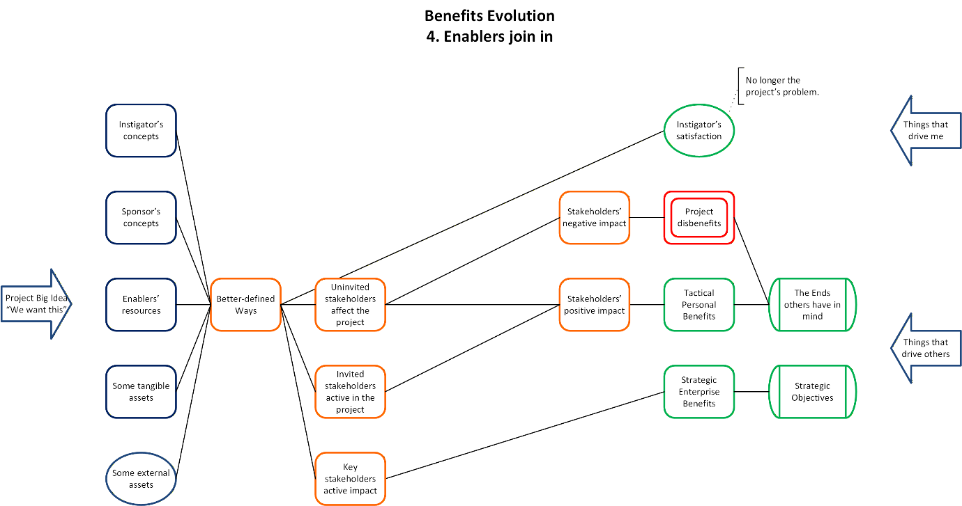

Evolving Objectives and Benefits for the Sponsor and Enablers
Benefits evolve throughout the project as a mixture of two strands.
Strategic enterprise-level benefits come from the key stakeholders who have active impact on the project, e.g. valued clients. They are controlled by the sponsor as steward, holding the ring, managing the other stakeholders.
Tactical personal benefits are the rewards for participation or non-interference in the project. They go to invited stakeholders who are active in the project, e.g. valued consumers, and to uninvited stakeholders; consumers, fans, interested amateurs, active opponents.
The various stakeholders act together in the project in an inefficient market of opinion and negotiation. Added value isn’t bought with money at a market rate. It’s subjective to a great extent. We use methods and tools to apply some rationality to the choices made but they won’t ever be perfect and indisputable.
Our one inception benefit has exploded into a multitude of different benefits for different stakeholders. Some contribute to the strategic objectives if they are well controlled by the sponsor-steward. Others are more tactical, personal and parochial. The balance and quality of these benefits depends on how the two strands are managed.
The benefits will be hypothetical anyway unless someone manages their realisation. Each benefit must have an owner. Those owners come from our sponsor / enablers group.

- How do we get it done?
The Hot Potato
Benefit ownership can be summed up as, “I want this and will see that it happens.” If no-one will take responsibility then it won’t happen. The benefit ceases to exist. So benefit ownership is like a hot potato, someone always ends up holding it. Until responsibility can be handed off then it sits with whoever really wants it.
The inception benefit was owned by the instigator. Each new benefit that it expands into is owned by the sponsor until it is accepted by someone else. And so it cascades, they own their new benefits until handed over. What shouldn’t happen is a project full of benefits selected to satisfy its project board, all ‘owned’ by the project manager.

Benefits Management is the best application of scarce resources to select and deliver appropriate benefits to identified stakeholders
- What makes this better than Plan B?
The sponsor and the enablers above them who give approval are the ones who know what Plan B is (if it exists at all) and can judge if they are making the wisest investment. This is where wider value can be lost. If we don’t know the value of our project then we can’t compare it to the alternatives. If we don’t have a common currency between projects then we can’t compare them either. In a commercial enterprise the hurdle rate is a reasonably straightforward way to decide. Our project must make a certain return on investment or the money will be better spent elsewhere.
Life is more complex when the objectives are less tangible and people are reluctant to convert the currency of wellbeing or happiness to the currency of hard currency. Even when a basic price can be agreed, utility (getting the most) clashes with equity (fair shares) to make the choice between Plan A and Plan B even more debatable.
All the while, objectives and benefits evolve. Our project is ever changing in a wider sea of change. Von Clausewitz stresses the selection and maintenance of the aim. Benefits Management promotes the principle of starting with the end in mind. The leader’s art includes the skill to select the best objectives (better than Plan B) and the skill to recognise when they are no longer the best and not maintain objectives that waste value.
Having started with one inception benefit, the instigator gets what they want, perhaps in the end we are left with one benefit, the sponsor / enablers are satisfied with the results. Everything in between is just a way of rationalising that satisfaction.

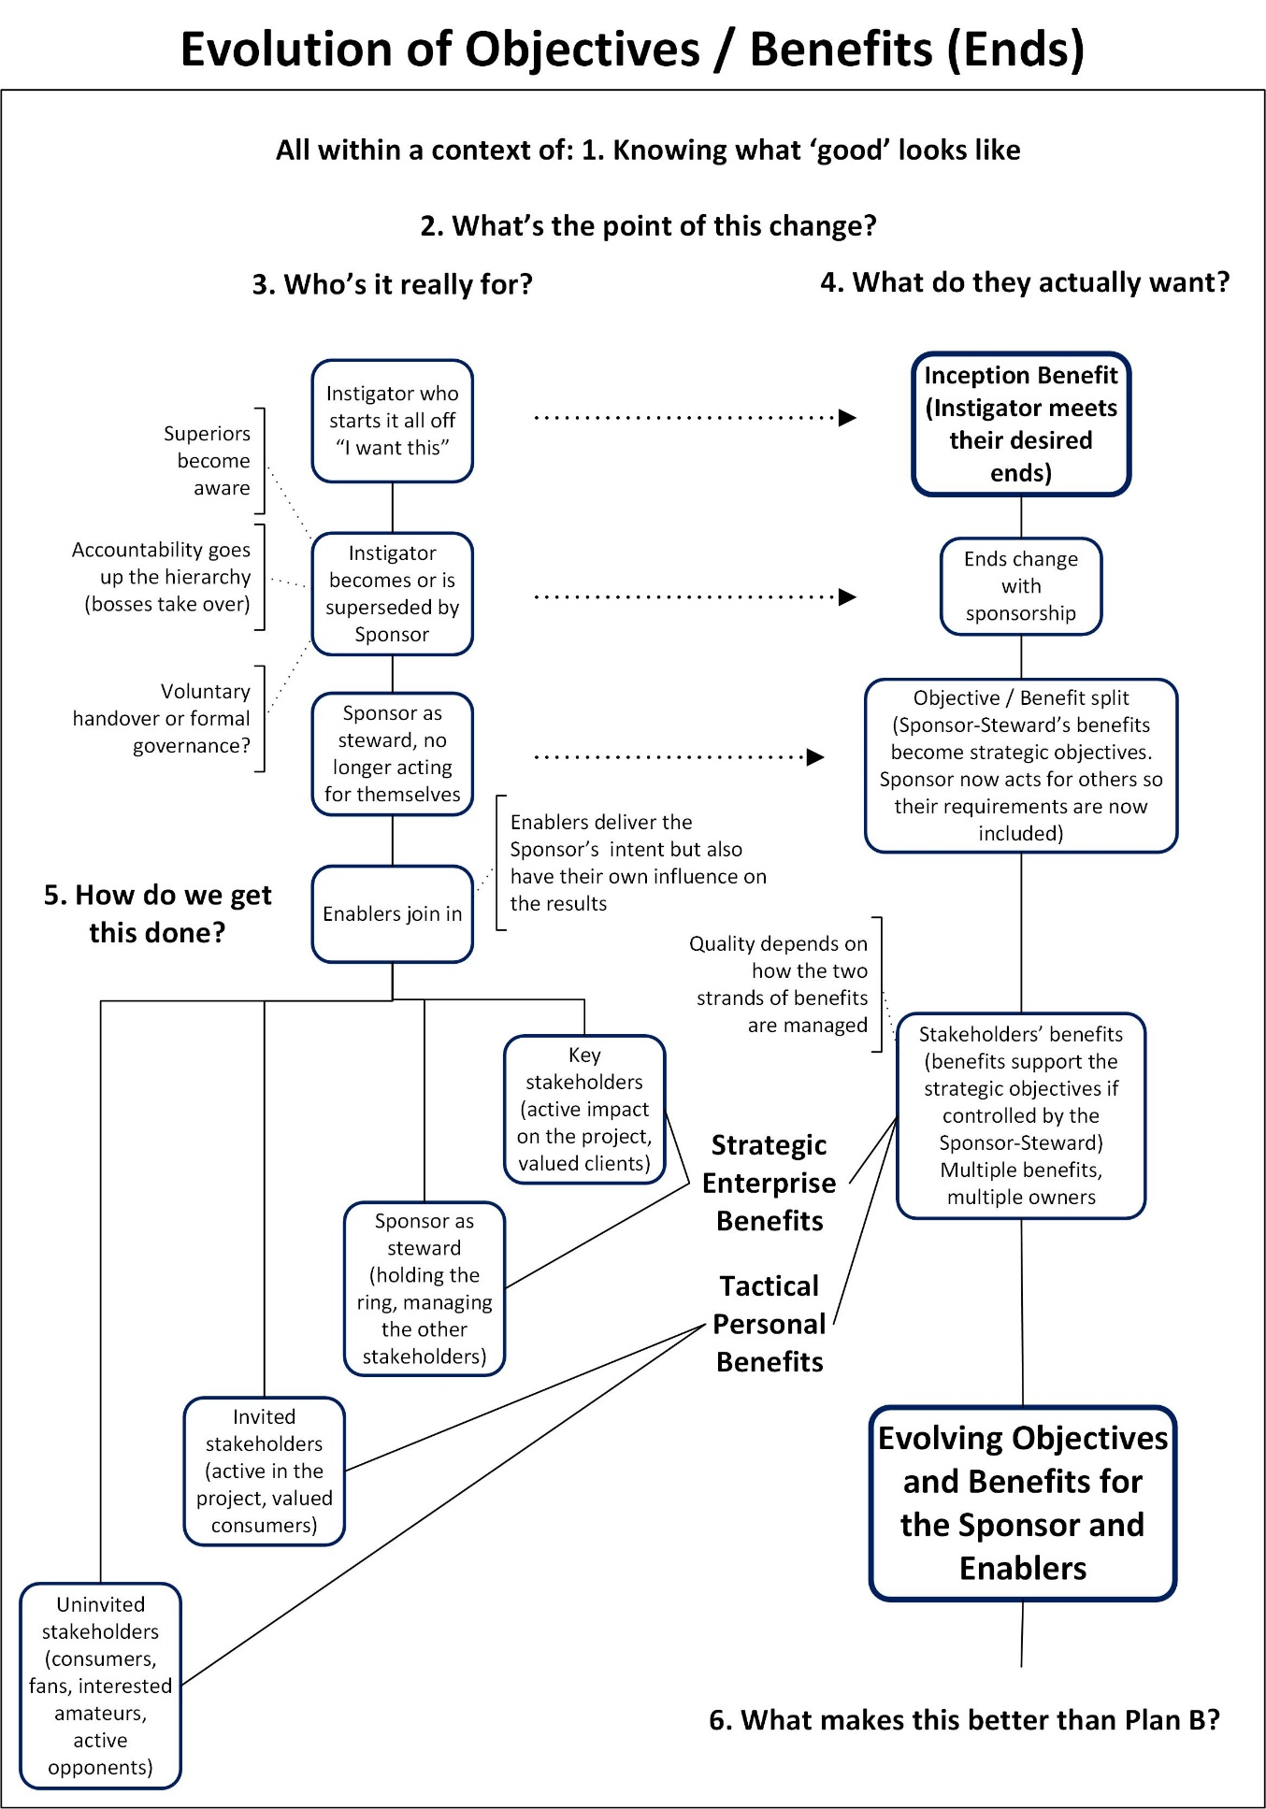

The use of Benefits Management in modern business is to lend an element of rationality to the exercise of power.

Once, in a cynical moment, I decided that Benefits Management could do little more than attempt to add a little rationality to leaders’ subjective decisions. If that’s the case, then Benefits Management can at least be a method to support the sponsor / enablers to deliver rationally ‘good’ benefits. We do this by:
- Starting with the end in mind (What does ‘good’ look like here? What’s the point of this change?)
- Choosing appropriate recipients (Who’s it really for?)
- Choosing appropriate benefits (What do they actually want? What makes this better than Plan B?)
- Ensuring ownership of the realisation of benefits (How do we get this done?)

I said at the start that the failure of so many projects could be due in part to the fact that we have a poor understanding of what defines success in the first place. All projects deliver benefits. The problem is that too often they are poor benefits for the wrong people.
Benefits Management gives us a better understanding of what constitutes success, i.e. the objectives and benefits, and how that success evolves throughout the project. It gives us tools to control that evolution. That way, our sponsor / enablers’ satisfaction won’t just be self-satisfaction, it will be valid, an achievement to make them proud.

