Benefits-led Agile
What’s the story here? Benefits-led Agile development that puts a strategic wrap around tactical Sprints. There’s a parallel story for another day about putting an Agile sense of urgency into business policy and strategic planning. The ideas offered here are based on limited experience of Agile in what may be an atypical setup. The purpose of this paper is to get feedback to develop these ideas into a generally applicable proposal.
Agile delivers time-bound pieces of functionality. It has the flexibility to adapt to circumstances and lessons learned from previous development sprints or time boxes. Sprints begin with Product Owners describing their requirements and prioritising what gets done next. MoSCoW (must, should, could, won’t do) selection of what they want and the order they want it in sets the Product Backlog for the developers to concentrate on in the next round of work.
It’s about delivering product increments which suggests that you’ve a fair idea of what the end product should do, you’ve got a partially working model and the developers are adding that quality polish. It all seems a little tactical.
Where’s the assurance that the optimum choices are being made in the first place? Where’s the strategy? Benefits-led Agile development puts a strategic wrap around tactical Sprints.
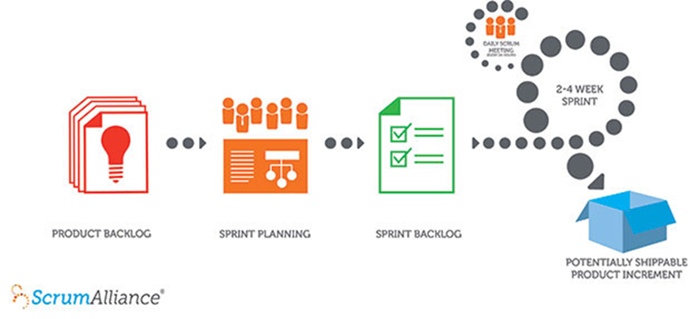
Benefits Management can work well in an Agile setting but it may have to run to keep up. Traditionally, programme management sets more flexible targets than individual projects do. The scope and timescale of programmes are such that it’s clearly recognised that the world is moving on as they happen. Programme objectives can still be SMART, they are just a bit more fluid than project ones.
The use of iteration, feedback and performance management (‘so far, so good’ benefits tracking) in programme benefits management helps keep the programme on track to deliver value, even when that value begins as being emergent and unforeseen.
Talk of product backlogs and product increments implies that behind them is a vision of the end-state product. We know roughly what we want in the end, it just needs some revision and polish.
A race with no finish line
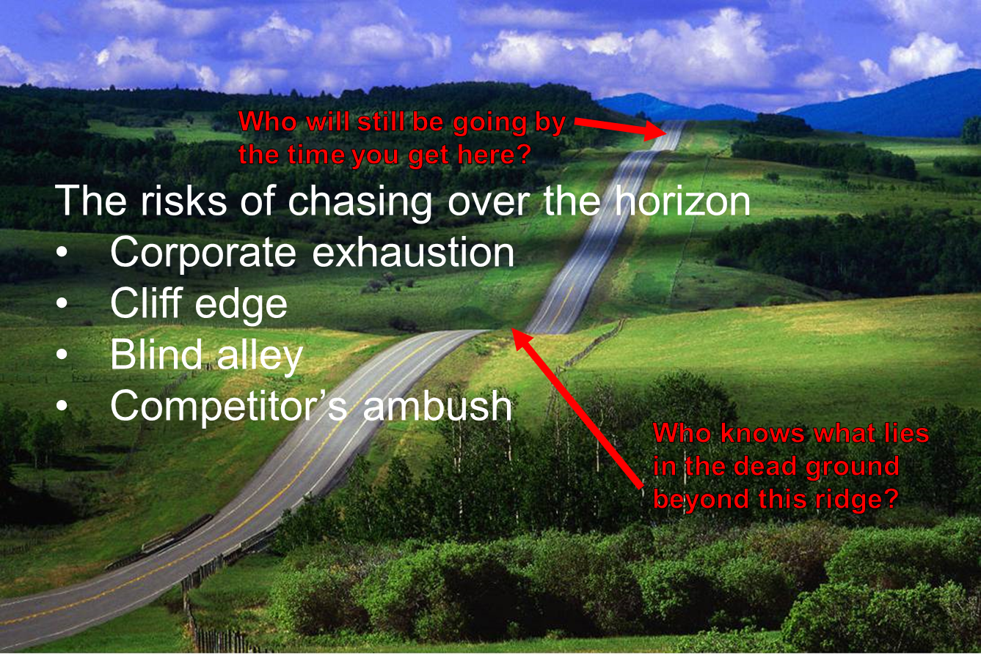
Here is the business context, the much bigger non-local problem. If this goes wrong then my local MoSCoW problems become irrelevant. All the business books tell us that we live in an environment of uncertainty and that continuous and faster business change is a necessity. How do we optimise continuous urgent change in an uncertain world? How do we cope when we don’t have a firm end-state product in sight?
Continuous, urgent change
The risks of chasing over the horizon:
- Corporate exhaustion, you can’t keep running forever
- Cliff edge, run straight into disaster
- Blind alley, can’t see where the road leads so take the wrong option
- Competitor’s ambush, you’re playing against other people who don’t want you to win so will deliberately set you up to fail

Tactical Bounds
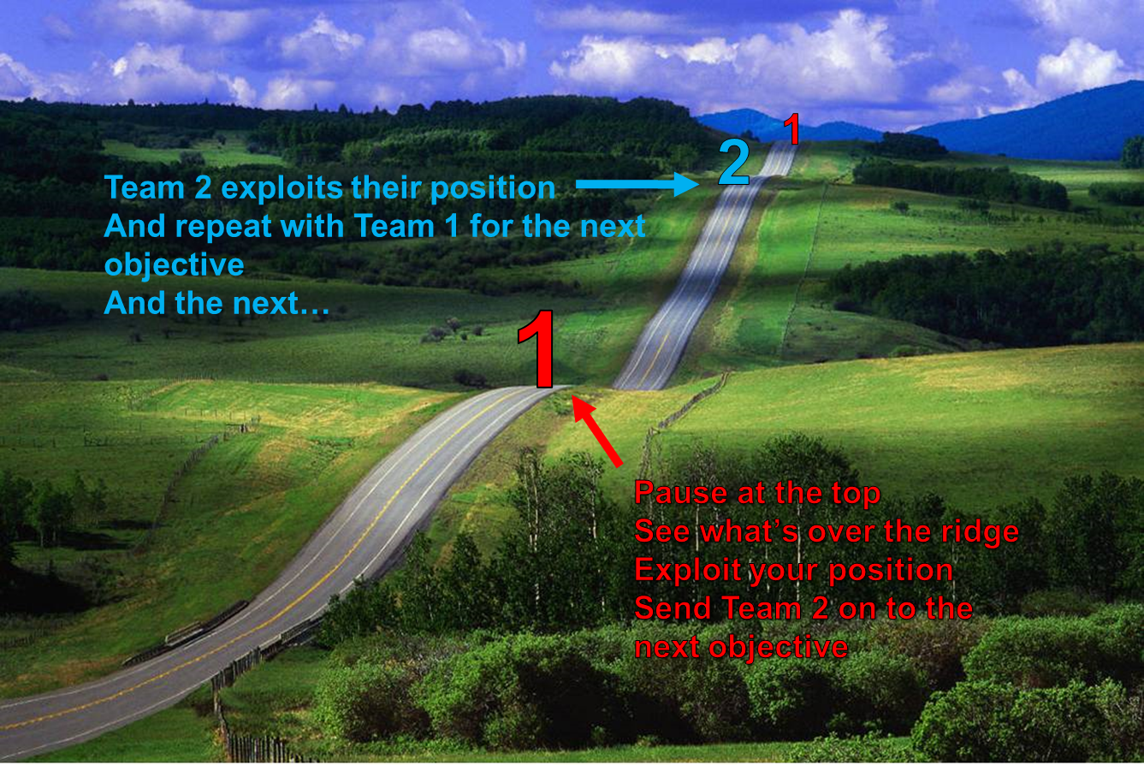
One way to cope is by moving in tactical bounds, one team at a time, one objective at a time. Choose an objective (pick the first hill). Commit sufficient resources to take it. Secure the hill. Send the next team up the next hill, and so on. In a bit more detail:
- Understand the context in which you operate
- Choose Objective 1
  - Commit resources
  - Plan it
  - Achieve it
  - Exploit it
  - Establish a Firm Base
  - Use it as resources for the next bound
- Confirm the context
- Choose Objective 2
  - And so on…
Tactical Bounds give you the security to move forward. The firm base gives you the resources to use in your next venture. In Boston Box terms, it’s your Cash Cow that feeds the Problem Child to become a Star that turns into the next Cash Cow.
It also gives you somewhere to fall back to if Objective 2 fails. You don’t bet the whole firm on one throw of the dice.
Whether you split Team1 and Team 2 equally, or have more than one team depends on your circumstances and preference. You may advance ‘one up and two in reserve’ for caution or ‘two up’ if there’s an urgent need and big prizes to be had.
The same approach can be scaled down for an Agile project. We can start with a SMART objective that’s defined by its boundaries, e.g. benefits of no less than X, delivered by time Y in location Z. The Benefits Realisation Plan will be co-ordinated with the Agile timetable and benefits will be staged with the project deliverables.
Decision cycle:
Tactical Bounds helps you avoid a blind charge in any / all direction(s) but it mustn’t stifle any sense of urgency. (Appropriate) speed is always of the essence.
The speed at which decisions are taken is crucial. There will be windows of opportunity, a sense of urgency, lost chances to consider. A good choice may fail because it was taken too late. There will always be some trade-off between the quality of the decision and the time you take to make it.
Where Benefits Management starts running to keep up is in the need for constant review that fits with the Agile timetable. The developers meet regularly to assess what they achieved last period and how it will affect the plan for the next. This has to be controlled by the business’s assessment of the relevant benefits realisation. Every change to the plan must be weighed against the question, “Will it maintain or enhance the objective?” The business will consider:
- Will the change realise our desired benefits?
- Will it take us off-track?
- Will it offer new opportunities that we must take?

A developer’s flash of inspiration takes seconds, “I can tweak the code and give you X”. The appraisal of X is a significant exercise in quality control. The business skill will be in allocating the appropriate time and effort that trades off the new value you may get from changing the project specification against the cost and delay of assessing that value and making the change.
It won’t be an easy task and it will require some mental stamina to keep up. However, it’s a task that has to be planned to ensure that your project delivers benefits and not just capabilities.
Sometimes speed has to trump assurance so how do you make the best choice in the limited time allowed?
Use tools to help you choose good things fast.
Some are psychological, ways of thinking that get you past the traps we all fall into when we see shiny things that we want.
Others are more practical, devices to add rationality and logic to your choices. The more you can structure and program the administrative decisions, the more mental effort you can devote to the creative stuff.
If we treat each decision as a project then we should look to a rational method for its successful delivery. Given that strategic decision making is a human activity, we can never entirely eliminate human weaknesses and strengths, we are faced with human subjectivity throughout the decision project lifecycle. Here we concentrate on the two key points, knowing where to start and knowing when to stop.

The Subjective Start - Starting with the End in Mind
The purpose behind any course of action has a direct and significant effect on the way it is undertaken. The reasons why affect the ways we go about things. If Nelson had gone off to Trafalgar simply with the intent of using up his budgeted stock of gunpowder then he would have fought a very different battle from the one that actually took place.
A less war-y analogy, football is a competitive sport where the obvious objective is to win the game. Situations differ between matches though and a football manager’s side and tactics will adapt to the objective:
- Win at all costs
- Put on a show for the fans
- Play for the league points
- Pace yourselves for the next match

The same applies for any project, the ends affect the means and ways. Projects talk of acceptance criteria, the things that decide when the project has ended successfully, a sort of, “No-one goes home until…” Define your acceptance criteria in terms of objectives and benefits before you start. Don’t install the kit and then wonder what to do with it.

The Subjective Stop - Endgame
There will come a point when the analysis has to end and the decision is made, where you stop asking, "Why" and start acting. The trick is knowing that you've reached the right point at which to stop.
Starting with the end in mind requires a clear and simple description of what that end will be. We can affect the process through the way we describe the end state. Only a very confident (or deluded) chess player would describe the endgame in terms of where the pieces will be. Yet we are often very granular in describing our programme objectives. Too often Output Based Specifications run to hundreds of pages with sheets of individual requirements, desires and benefits, a pound saved here, ten minutes there, etc.
This sort of mass objective twists individual priorities and breaks down any common purpose. It’s like playing chess as a team with each player responsible for a single piece. Each heads for its assigned position and sits there without contributing anything to the whole or supporting its team mates in winning the game. That’s why clear and simple objectives are crucial.
Psychological tools
There’s some excellent stuff on the ways that psychology affects economic decision making in Daniel Kahnemann’s book Thinking, Fast and Slow. For now, just be aware that these things exist. Recognising them is a step towards compensating for them.
Prediction:
- Optimism Bias – Expecting too much in terms of results, cost and time despite previous experience. This is now recognised and often included in business cases. Which means people have started gaming with it, claim double.
- Strategic Misrepresentation – Flyvbjerg, conscious deliberate lying to get the business case approved. International analysis of transport infrastructure, just about every business case lied about the potential benefits to be achieved.
- Anchoring – Anchor on the first estimate, no matter how inaccurate and then fail to change sufficiently despite knowing it was wrong. It’s why salespeople start on an impossibly high note, “This is the best thing since sliced bread”. It will still feel that way even when the facts have destroyed their argument.
- WYSIATI – What You See Is All There Is (Kahnemann), ignoring the existence of other evidence, failing to look for alternatives.
- Correlation, not Causation – Assuming that two things happening at the same time are connected cause – effect when they could be coincidence.

Delivery:
- Illusion of Control – Assuming it all goes to plan… Belief that you have full control of the situation, not mitigating the risks.
- Status Quo – Sticking with what you know, despite knowing that it doesn’t work.
- Confirmation Bias – Filtering the evidence to fit your expectations, seeing only what you want to see.
- Affect Heuristic – Like confirmation bias, seeing the positive in things (and people) we like, and negative in things we don’t. The halo effect of the singer, not the song.
- Framing – Making a choice dependent on the way the options are phrased. “It could be you!”, or “It’s almost certain it won’t be you.”
- Regression to the Mean – A knee-jerk reaction to a one-off. Reward and punishment are both usually followed by a more average result, hence we believe punishment motivates.
- Endowment Effect – Over-valuing what we have. Buy it for £1.00, won’t sell it for less than £1.10.

Picking the next Objective
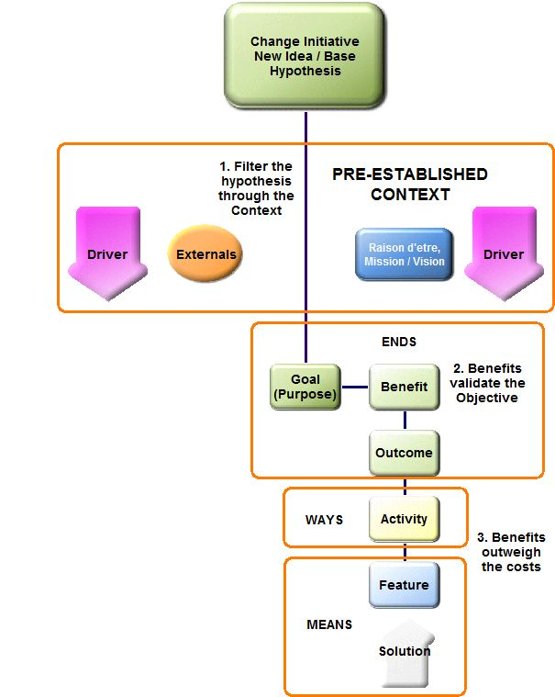
The Idea Test is a way of testing new ideas against your strategy, goals and context. Before running away with a brilliant new idea, it needs to be checked to see how good it really is and how well it fits with who we are and what we do. It contains three checks to take us from hypotheticals to practicality.
First, we have to understand the context in which we operate.
Choose to change - A new idea, Base Hypothesis. At this stage, this is probably a loose statement of, “Why don’t we…?”
First filter - test the Hypothesis against the context to see if it's relevant and feasible. Should we do it, can we do it?
Turn the Hypothesis into a Goal. “Why don’t we do X?” becomes, “We will do X, because…”
A Goal / Objective is something with purpose. Start with the end in mind. Then optimise the value of the goal. Determine the benefits required, expected.
Second filter – do the benefits validate the objective? Is your grand plan sensible? What’s it worth and who gets the value?
Next, plan to realise the ends. You want to do it, now work out how you are going to do it.
Third filter – is it practical and economical? Do the benefits outweigh the costs? Do you have a rational and sensible solution that will actually work in practice?
Practical tools
This is where practical tools come in. If you can program as much as possible into the decision making processes then you save thinking time that you can put to better use.
One of the best practical tools is the Benefits Dependency Network. It is one of the key tools in the Benefits / Value arena. It shows the chains of cause and effect between what you use, do and want, i.e. between the means, ways and ends.
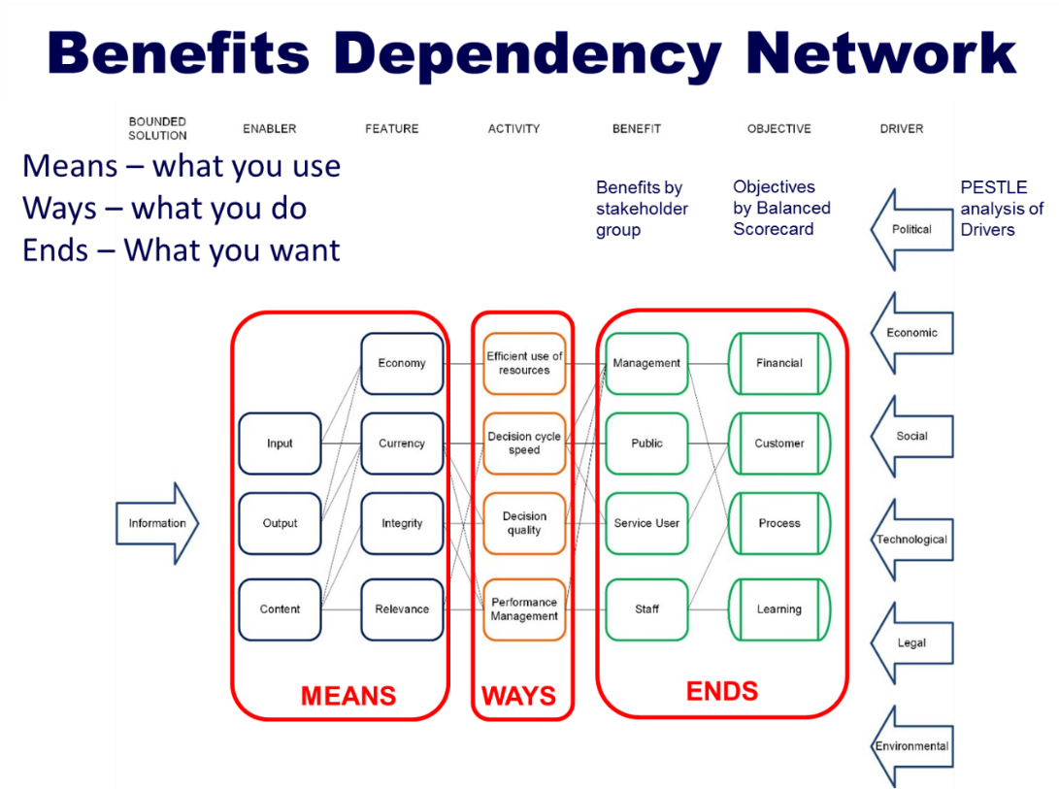
The Agile development is the tactics that control how the strategy is delivered. In the Sprint we work towards creating the product increments, the capability that serves our purpose. We make the Means that serves the Ends. Benefits-led Agile is the approach that governs the ideas selected to feed this line.
If new capability is discovered then we have to check that it’s useful. New Means may give us new Ends, a new objective. So we test the idea, select or discard the Objective and move on.
The BDN sets the strategic boundaries. It determines the limits of what’s desired and the scope of the solution. The Agile development is the tactics that control how the strategy is delivered.

Decision Cycle speed
So far, we’ve concentrated on the quality of the decisions made. We’ve acknowledged that you can’t take forever worrying about what to do next. Speed is of the essence. That is why a structured process helps by programming the admin decisions and freeing up thought for more creative and productive use.
The benefits management approach is an iterative process with loops within the loop. It’s essential if the benefits are to be optimised that there is permission to step back and reconsider. Obviously, this has to occur within rigorous change control.
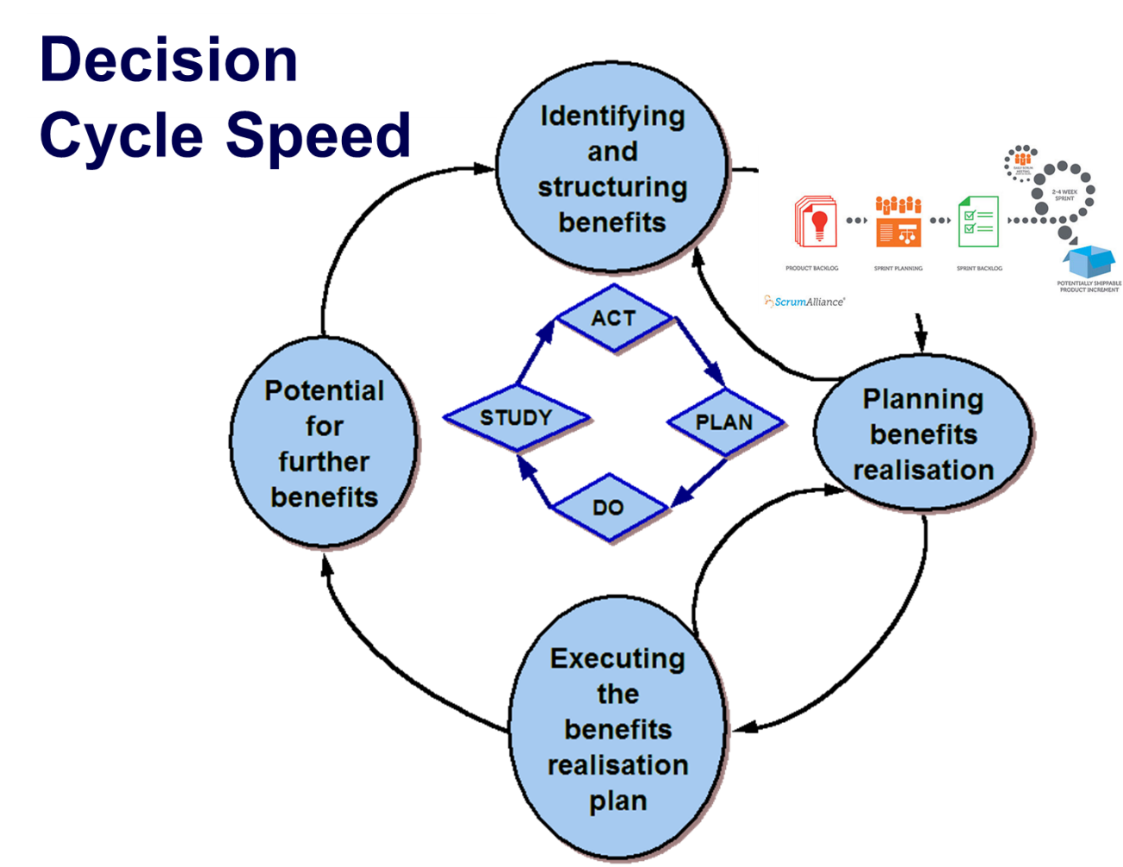
Where to start? Remember starting with the end in mind? Picking the right thing to do for the right reasons.
Start with the Act, make a decision, even if it’s only deciding to make a decision. The plan will then be a quick consideration of what to do and how to do it. The first few laps of the loop will be so quick that it doesn’t really matter where you jump in.
Remember, it’s an iterative process between stages as well as the whole process.
This represents a virtuous circle.
Identifying and Structuring Benefits - The proposed benefits are identified, and for each proposed benefit suitable business measures are developed - both financial and non-financial. The benefits are structured in order to understand the linkages between technology effects, business changes, and overall business effects e.g. business objectives. At this stage, it becomes possible to assess the overall business benefits. It is also possible to assess the “current situation” with the measures that have been developed.
Planning Benefits Realisation - For each benefit, specific responsibility for realising the benefit is allocated within the business. The required business changes are analysed and planned for, and a “benefits realisation plan” is produced. At this stage, the full costs of both technology development and business changes can be assessed, in order to make a fully informed judgement as to the viability of the proposed project. Any intended benefit for which responsibility cannot be allocated and for which a delivery plan cannot be developed should be rejected at this stage.
Executing the Benefits Realisation Plan - Alongside the implementation of the proposed technology, the necessary business changes as detailed in the benefits realisation plan are carried out. A series of progress reports will be generated as the programme / project moves through its tranches / stages.
Following the full implementation of technological and business changes, the previously developed business measures are used to evaluate the effects of the project. Review of “before and after” measures provides an explicit mechanism for evaluating whether the proposed business benefits have actually been delivered.
Potential for Further Benefits - As a result of the post-project review, it may become apparent that further benefits are now achievable, which were not envisaged at the outset. This stage provides the opportunity to plan for, and realise, these further benefits.

Rationality in MoSCoW
Scrum and Product Backlog has an assumption that the Product Owner has already done the analysis to select the best product increments to go in the Backlog. What have they used to make their MoSCoW selection? Where is their sense of proportion?

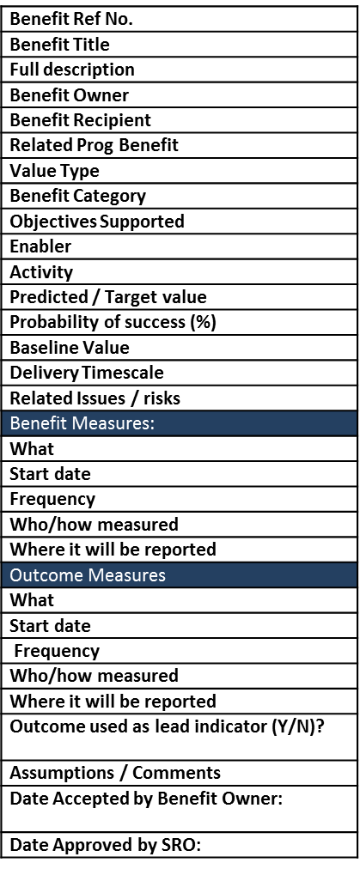
Put rationality into MoSCoW
Use a Benefit Profile to capture requirements
- Who’s it for?
- What do they want to see happen?
- How big a deal is it?
Fit the tool to reality, make it work in context

Ends from Ways from Means

The Benefit Profile form has a lot of headings and can look intimidatingly methodical (or just plain boring) at first sight. It works well when everyone remembers that the tool should fit reality and we don’t force reality into the tool. It’s not so much the detailed list as the things that go into it. They are cultural and fit the enterprise in question.
The aim is to get the right thinking into the requirement, “I want these results (i.e. benefits) and I think this piece of functionality (product increment) will deliver them in the context in which I operate.” We phrase the requirement as Ends from Ways from Means, starting with the End in mind. Having drawn the BDN, we already know what we want (at a high level) and how the connections work. This form puts a bit of rigour and detail into the requirements.
It gets us away from the instant answer of, “I want this solution, the reasons are self-evident but hard to express”, “It’s a no-brainer, I just can’t put it into words”.
By describing each item in the Product Backlog using the same form and process, we can compare our options in a rational way by seeing their value relative to each other. The cultural context of the enterprise will have its own significant impact here. Some groups will go totally anal in the detail they complete. If that works for them, fine. Others will be fast and loose. Again, it’s whatever works. Where both types of group gain from the same process is that they’ve filled in the boxes in the form, in the right order, using a rational mindset and so have both raised the quality of the choices they make.
Things to watch
Theory is one thing, practice is so often very different. The ideas offered here are not the perfect answer. Even if they were, success would be a matter of how they were applied in reality. There are a number of obstacles to avoid. Here are three typical ones for example.
A preference for action over thinking keeps projects rattling along, but in the right direction? “Something must be done. This is something. We must do it.”, and we’re back to the race without a finish analogy.
Incubator test sites are great, as long as you resource them properly and let them fail effectively if they have to. They’re good for quick trials but they need spare resources and thinking time and you must be able to drop the ones that won’t work.
Know when to pull the plug and don’t blame the failures. Don’t even call them failures if you can avoid it. Effective failure means don’t bet the farm. No make or break gambles. Remember the business context and the Tactical Bounds.
Conclusion
It looks like successful Benefits-led Agile requires a high level of corporate fitness, the speed to match the rate of development and the stamina to keep going. It also needs the skill to set the right competitive pace. The right tools help as well. Who says you have to run all the way when you can occasionally take the bus.

© David Waller, Keldale Business Services Ltd 2015

